Paper Title

1. **Preprocessing: Filtering & Segmentation**

PanTompkins algorithm

Wavelet Transform

1. **Feature Extraction**

Hilbert-Huang Transform(HHT)

Hidden Markov Model (HMM),

1. **Classification & Classifier**

A Shannon energybased approach

1. **Accuracy**

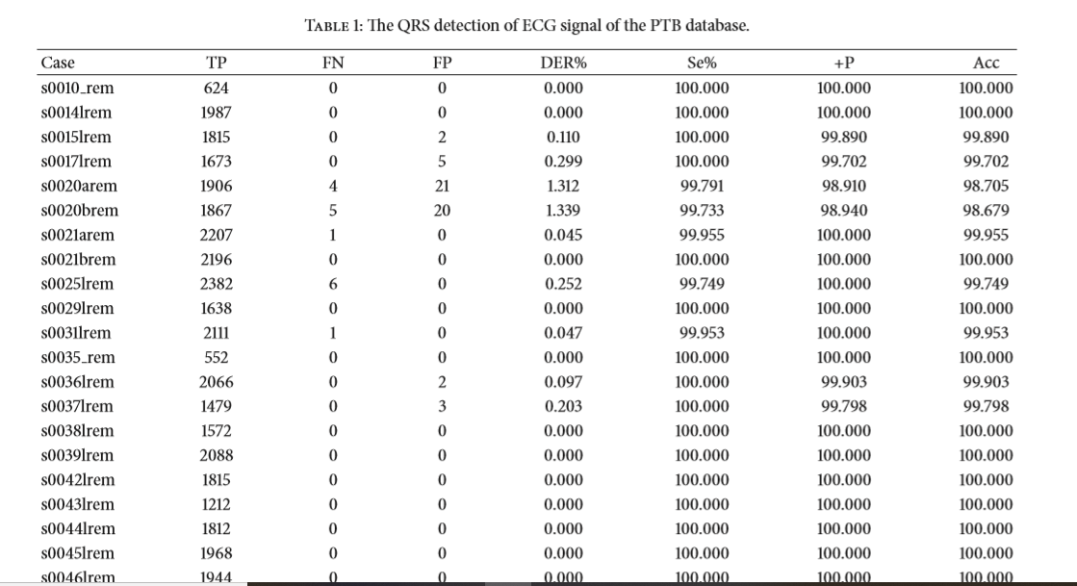

1. **Two Leads or One Lead ? In case of two leads .. how classification of two leads is merged to have final decision ?**
2. **Classes**
3. **Data sets**

PTBDiagnosticECGDatabase(PTBDB)